**Lab – 15: Enable Application Proxy and register the connector.**

**Objective:** The objective of this lab is –

* To enable Application Proxy, install and register the connector.

**Prerequisite:** EMS Enterprise Mobility + Security E5. A server running Windows Server 2012 R2 or 2016, on which you can install the Application Proxy Connector

**Steps:**

1. Sign in to your Azure Portal, by using the link - **https://portal.azure.com/**. Enter your credentials and click Sign In.

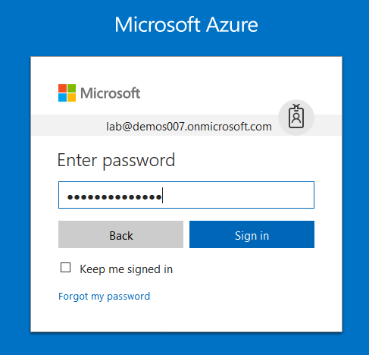

1. Microsoft Azure AD Dashboard will open.

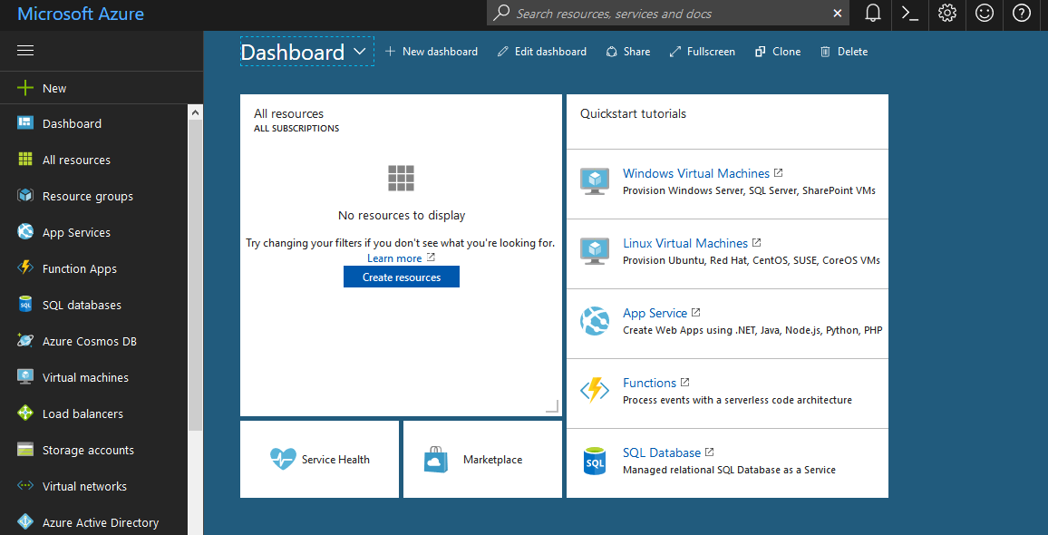

1. In the left-hand navigation pane, click the **Azure Active Directory** service, click **Application proxy**. Application proxy provides single sign-on (SSO) and secure remote access for web applications hosted on-premises.

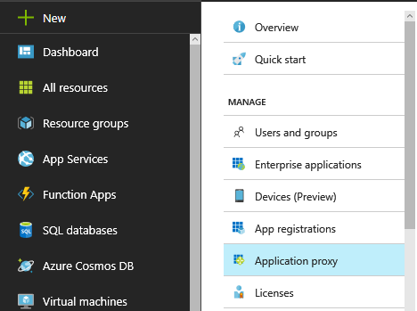

1. Select **Download Connector**.

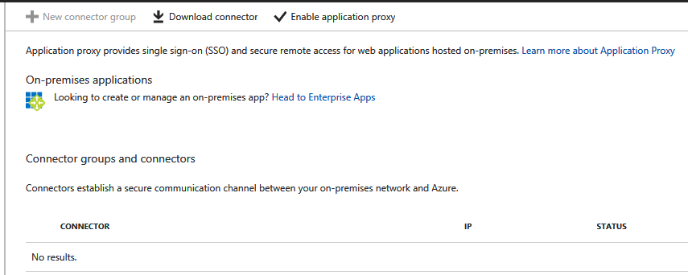

1. You’ll be redirected to **Azure AD Application Proxy Connector Download** page, click **I Accept the license terms and privacy agreement** and download by clicking the **Download** button. Then, run **AADApplicationProxyConnectorInstaller.exe** on the server you have prepared.



1. To install follow the instructions in the wizard. During installation, you are prompted to register the connector with the Application Proxy of your Azure AD tenant. Provide your Azure AD global administrator credentials. Your global administrator tenant may be different from your Microsoft Azure credentials.
   1. Make sure the admin who registers the connector is in the same directory where you enabled the Application Proxy service. For example, if the tenant domain is contoso.com, the admin should be admin@contoso.com or any other alias on that domain.
   2. If IE Enhanced Security Configuration is set to **On**, on the server where you are installing the connector, you may not see the registration screen. To get access, follow the instructions in the error message. Make sure that Internet Explorer Enhanced Security is off.
2. For high availability purposes, you should deploy at least two connectors. Each connector must be registered separately.
3. So, in this way you can install and register the connector.